Next-Generation Oracle ERP Dashboard Using Oracle APEX and REST APIs

Project Overview
This project demonstrates how Oracle APEX can be used to build a modern ERP dashboard that simulates real-time integration with Oracle E-Business Suite / Oracle Fusion using REST APIs and PL/SQL. I built a Next-Generation ERP Dashboard in Oracle APEX that integrates REST APIs, tracks ERP KPIs, and provides executive-level insights with real-time error monitoring.
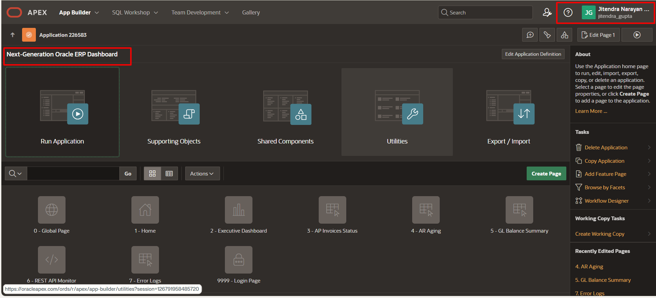

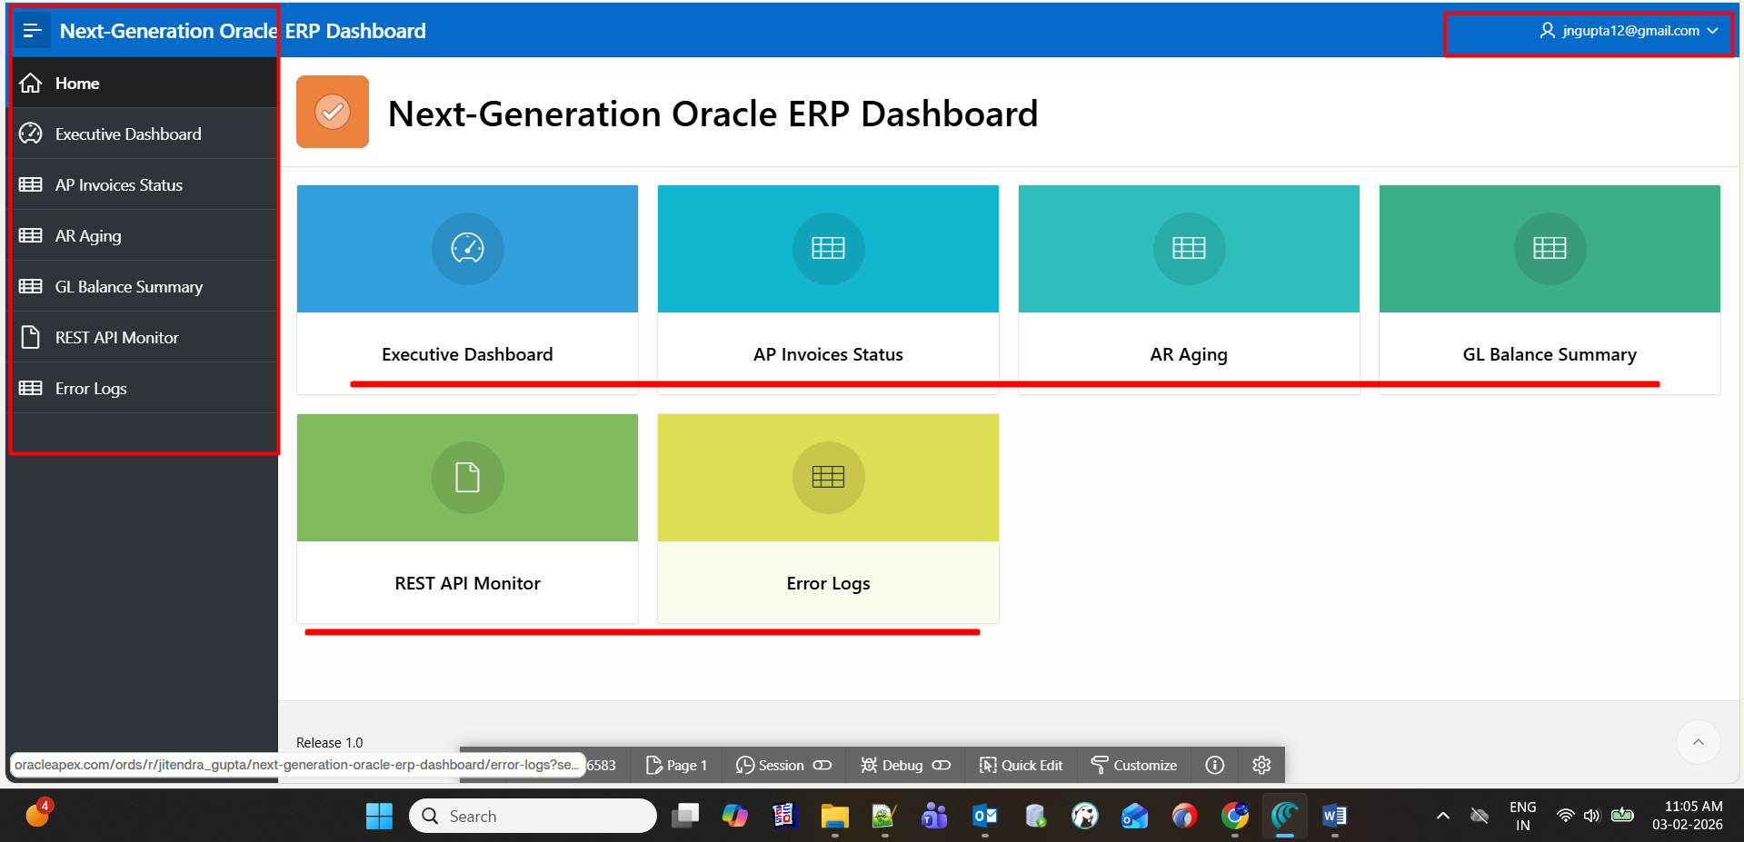

select LOG_ID, API_NAME, REQUEST_DATE, HTTP_STATUS, STATUS, ERROR_MSG from "ERP_REST_LOG" a

select KPI_NAME, KPI_VALUE, LAST_REFRESH from "ERP_KPI_SUMMARY" a

What to Do in This Project (Simple Explanation)
In this project, you are building a central ERP monitoring dashboard using Oracle APEX that:
- Collects ERP data (AP, AR, GL) via PL/SQL and REST APIs
- Stores summary KPIs in a database table
- Logs REST API activity and errors
- Displays everything in clean executive dashboards

Step-by-Step What You Do
- Create ERP KPI tables
  - Store summarized finance data
  - Avoid heavy ERP queries on dashboards
- Write PL/SQL programs
  - Refresh KPIs (AP count, AR amount, GL balance)
  - Prepare logic for real ERP data later
- Integrate REST APIs
  - Simulate Oracle Fusion / EBS REST calls
  - Capture response status & errors
- Build APEX dashboards
  - KPI cards
  - Interactive reports
  - REST error monitoring
- Prepare for future ERP integration
  - DB Links
  - Oracle Integration Cloud
  - AI-based insights

2️ Purpose of This Project (Why This Project Exists)

Primary Purpose
To show how Oracle APEX can act as a modern ERP control tower.
Traditional ERP systems:
- Have complex screens
- Are slow for executives
- Don’t show API failures clearly
This project solves that by providing:
✔ Fast KPIs
✔ Centralized ERP visibility
✔ API monitoring
✔ Executive-friendly UI

Technical Purpose
Area | Purpose
Oracle APEX | Build low-code ERP dashboards
PL/SQL | Business logic & aggregation
REST APIs | ERP system integration
Logging | Production-grade error tracking
Tables | Performance optimization

3️ Why This Project Is Important (Oracle Perspective)
Oracle customers today want:
- Cloud-native ERP dashboards
- Low-code solutions
- API-first architecture
- Fusion & EBS coexistence

4️ Real-Time Business Use Case

Example Scenario
A CFO wants to know:
- How many AP invoices are pending?
- What is the current GL balance?
- Are ERP APIs failing?
Instead of logging into:
❌ EBS
❌ Fusion
❌ OIC
They open one APEX dashboard.

5️ What Advantage You Get in the Future (Very Important)

Career Advantages
This project helps you become:
✔ Oracle ACE candidate
✔ ERP Technical Architect
✔ APEX + Fusion Integration Expert
✔ OIC / REST Specialist

Technical Advantages
Skill | Benefit
Oracle APEX | Enterprise app development
PL/SQL | Advanced business logic
REST APIs | Modern ERP integrations
ERP KPIs | Finance domain mastery
Logging | Production-ready design

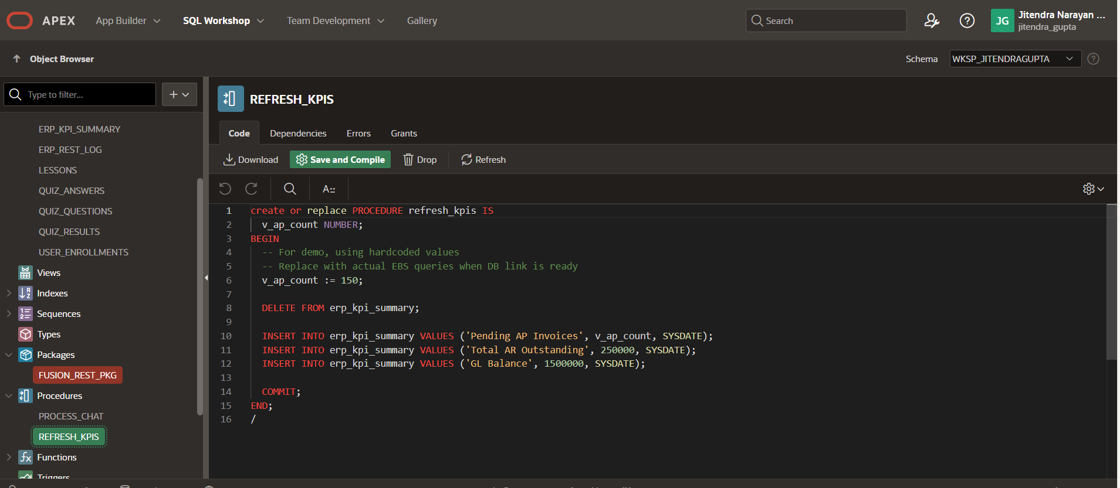
create or replace PROCEDURE refresh_kpis IS
v_ap_count NUMBER;
BEGIN
-- For demo, using hardcoded values
-- Replace with actual EBS queries when DB link is ready
v_ap_count := 150;

DELETE FROM erp_kpi_summary;

INSERT INTO erp_kpi_summary VALUES ('Pending AP Invoices', v_ap_count, SYSDATE);
INSERT INTO erp_kpi_summary VALUES ('Total AR Outstanding', 250000, SYSDATE);
INSERT INTO erp_kpi_summary VALUES ('GL Balance', 1500000, SYSDATE);

COMMIT;
END;
/
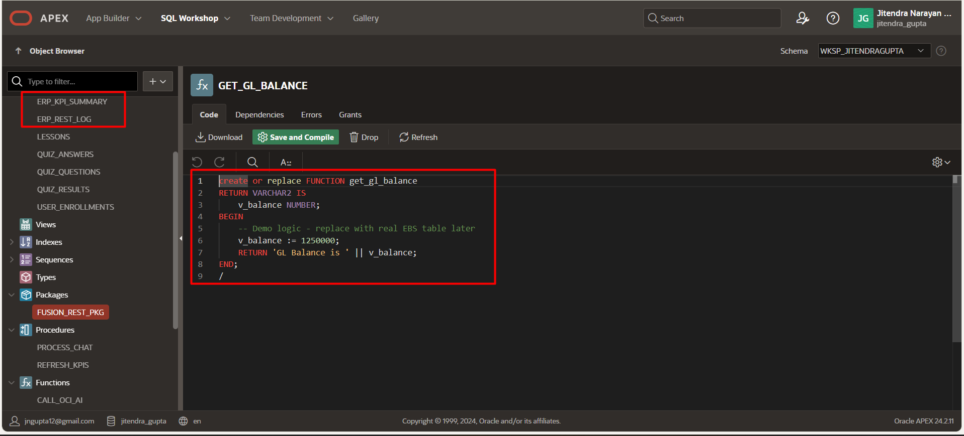

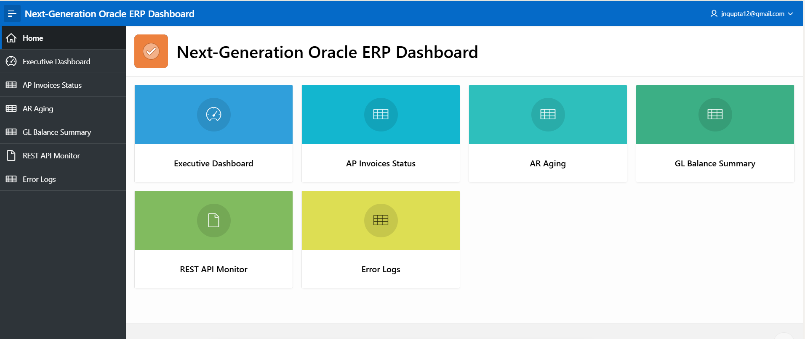

1️ DATABASE TABLES (RUN FIRST)

🔹 REST API Log Table
CREATE TABLE erp_rest_log (
log_id NUMBER GENERATED ALWAYS AS IDENTITY PRIMARY KEY,
api_name VARCHAR2(100),
request_date DATE DEFAULT SYSDATE,
response_clob CLOB,
http_status NUMBER,
status VARCHAR2(30),
error_msg VARCHAR2(4000)
);

🔹 KPI Summary Table
CREATE TABLE erp_kpi_summary (
kpi_name VARCHAR2(100),
kpi_value NUMBER,
last_refresh DATE DEFAULT SYSDATE
);

2️ REST API INTEGRATION (FUSION CLOUD)

Create Web Credential (APEX UI)
Shared Components → Web Credentials
- Static ID: FUSION_REST_CRED
- Type: Basic / OAuth2 (Fusion user)

PL/SQL Package for REST Calls
CREATE OR REPLACE PACKAGE fusion_rest_pkg AS
FUNCTION get_ap_invoices RETURN CLOB;
END fusion_rest_pkg;
/
CREATE OR REPLACE PACKAGE BODY fusion_rest_pkg AS

FUNCTION get_ap_invoices RETURN CLOB IS
l_response CLOB;
BEGIN
l_response := apex_web_service.make_rest_request(
p_url => 'https://<fusion-host>/fscmRestApi/resources/latest/invoices',
p_http_method => 'GET',
p_credential_static_id => 'FUSION_REST_CRED'
);

INSERT INTO erp_rest_log
(api_name, response_clob, http_status, status)
VALUES
('FUSION_AP_INVOICES', l_response, 200, 'SUCCESS');

RETURN l_response;

EXCEPTION
WHEN OTHERS THEN
INSERT INTO erp_rest_log
(api_name, status, error_msg)
VALUES
('FUSION_AP_INVOICES', 'FAILED', SQLERRM);
RETURN NULL;
END;

END fusion_rest_pkg;
/

3️ JSON PARSING (FUSION RESPONSE)
SELECT jt.invoiceNumber,
jt.invoiceAmount,
jt.invoiceCurrency,
jt.invoiceDate
FROM JSON_TABLE(
fusion_rest_pkg.get_ap_invoices,
'$.items[*]'
COLUMNS (
invoiceNumber VARCHAR2(50) PATH '$.InvoiceNumber',
invoiceAmount NUMBER PATH '$.InvoiceAmount',
invoiceCurrency VARCHAR2(10) PATH '$.InvoiceCurrency',
invoiceDate DATE PATH '$.InvoiceDate'
)
) jt;

4️ EBS R12 SQL

🔹 AP Pending Invoices
SELECT ai.invoice_num,
aps.vendor_name,
ai.invoice_amount,
ai.approval_status
FROM ap_invoices_all ai,
ap_suppliers aps
WHERE ai.vendor_id = aps.vendor_id
AND ai.approval_status <> 'APPROVED';

🔹 AR Aging
SELECT hp.party_name customer_name,
SUM(ps.amount_due_remaining) outstanding_amount
FROM ar_payment_schedules_all ps,
hz_cust_accounts ca,
hz_parties hp
WHERE ps.customer_id = ca.cust_account_id
AND ca.party_id = hp.party_id
GROUP BY hp.party_name;

🔹 GL Balance Summary
SELECT gcc.segment1 company,
SUM(gl.accounted_dr - gl.accounted_cr) balance
FROM gl_je_lines gl,
gl_code_combinations gcc
WHERE gl.code_combination_id = gcc.code_combination_id
GROUP BY gcc.segment1;

5️ KPI REFRESH PROCEDURE
CREATE OR REPLACE PROCEDURE refresh_kpis IS
v_ap_count NUMBER;
BEGIN
SELECT COUNT(*) INTO v_ap_count
FROM ap_invoices_all
WHERE approval_status <> 'APPROVED';

DELETE FROM erp_kpi_summary;

INSERT INTO erp_kpi_summary VALUES ('Pending AP Invoices', v_ap_count, SYSDATE);
COMMIT;
END;
/
👉 Call this using APEX Button → Execute PL/SQL Code

6️ APEX PAGE SQL

🔹 KPI Card
SELECT kpi_name AS title,
kpi_value AS value
FROM erp_kpi_summary;

🔹 Fusion AP Report
SELECT *
FROM (
SELECT jt.invoiceNumber,
jt.invoiceAmount,
jt.invoiceDate
FROM JSON_TABLE(
fusion_rest_pkg.get_ap_invoices,
'$.items[*]'
COLUMNS (
invoiceNumber VARCHAR2(50) PATH '$.InvoiceNumber',
invoiceAmount NUMBER PATH '$.InvoiceAmount',
invoiceDate DATE PATH '$.InvoiceDate'
)
) jt
);

7️ ERROR MONITOR PAGE
SELECT api_name,
request_date,
status,
error_msg
FROM erp_rest_log
ORDER BY request_date DESC;

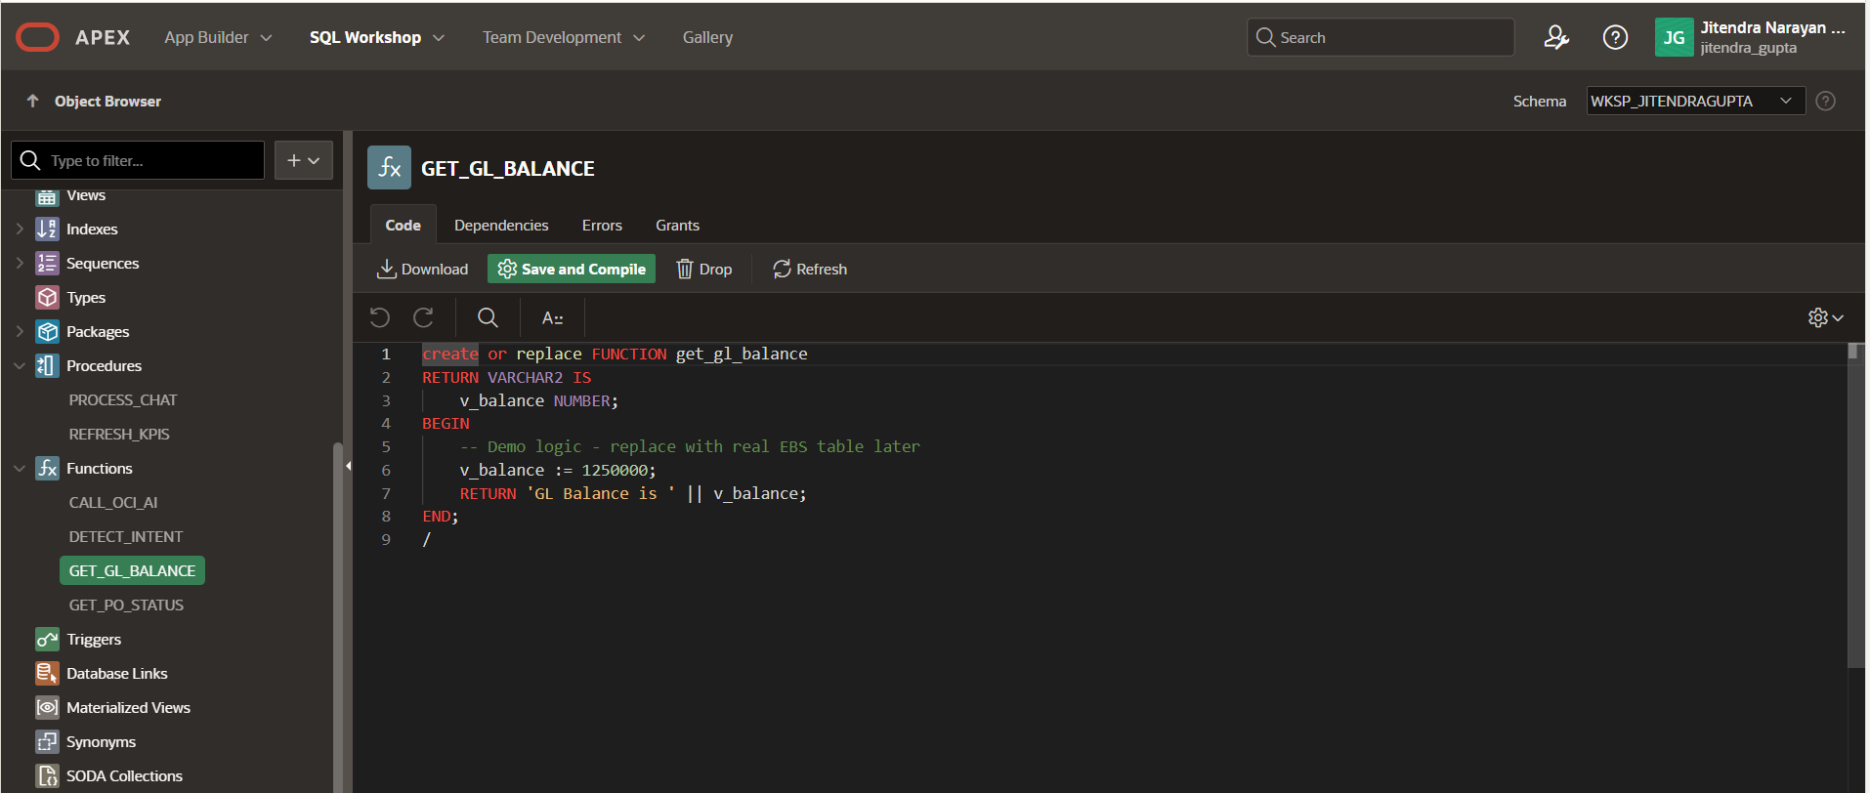
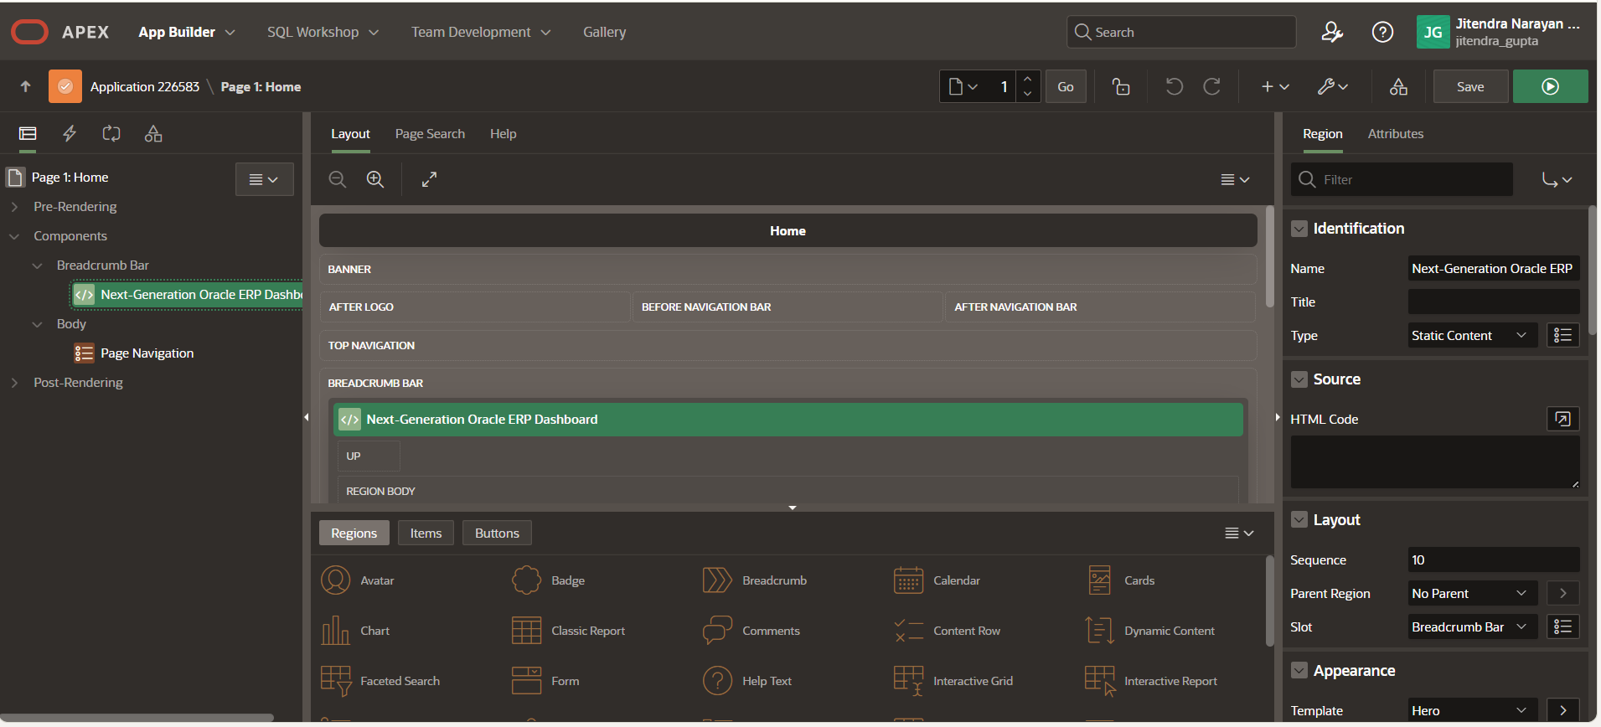

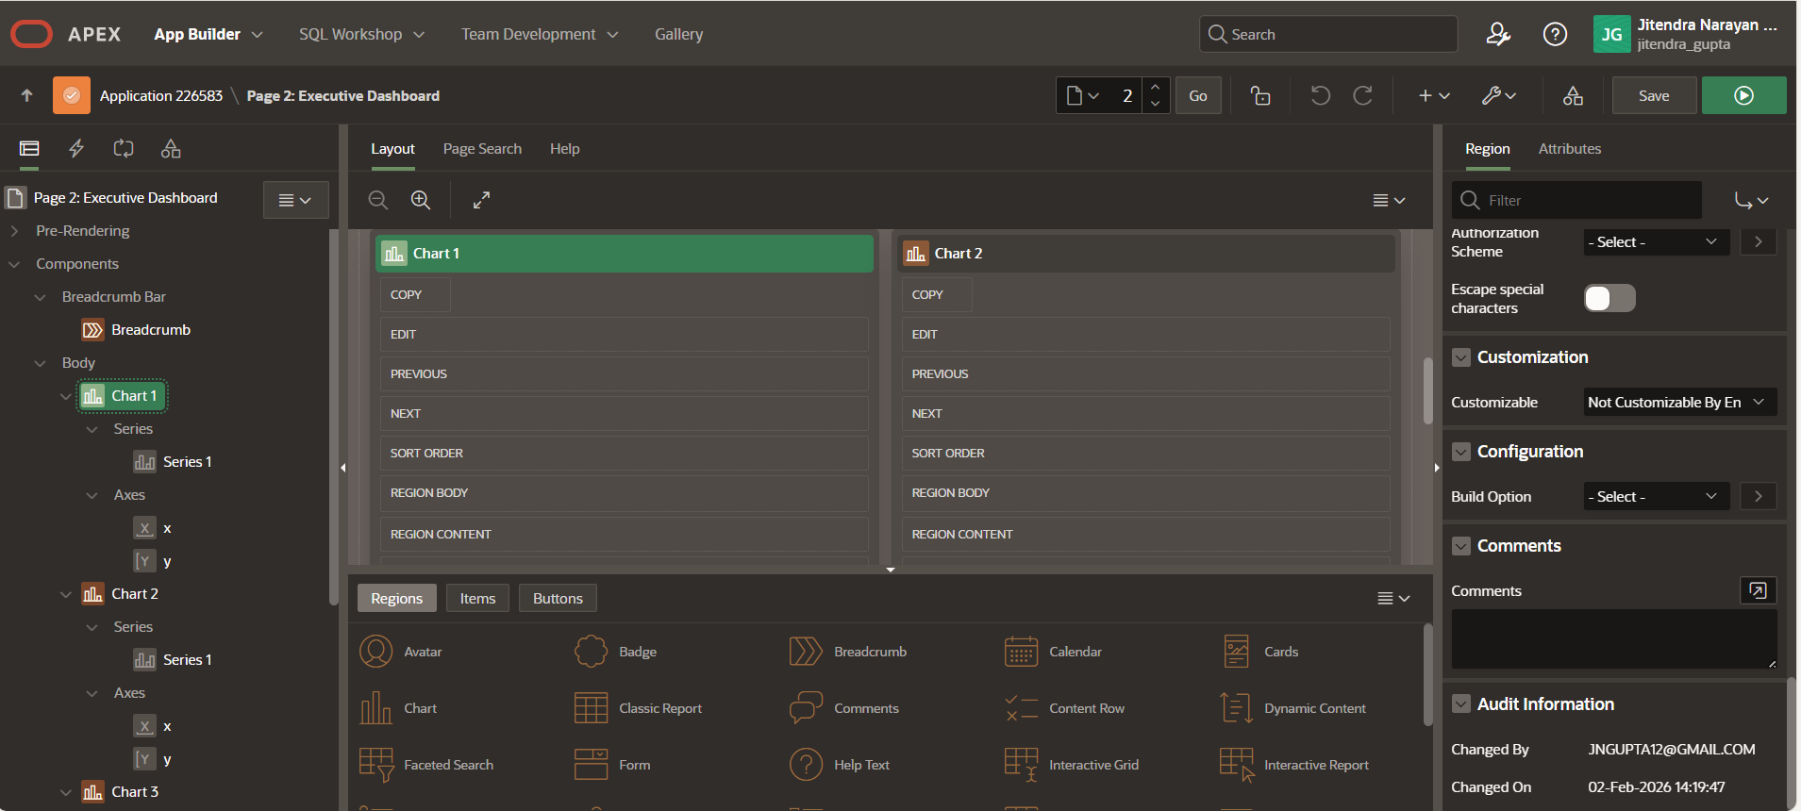

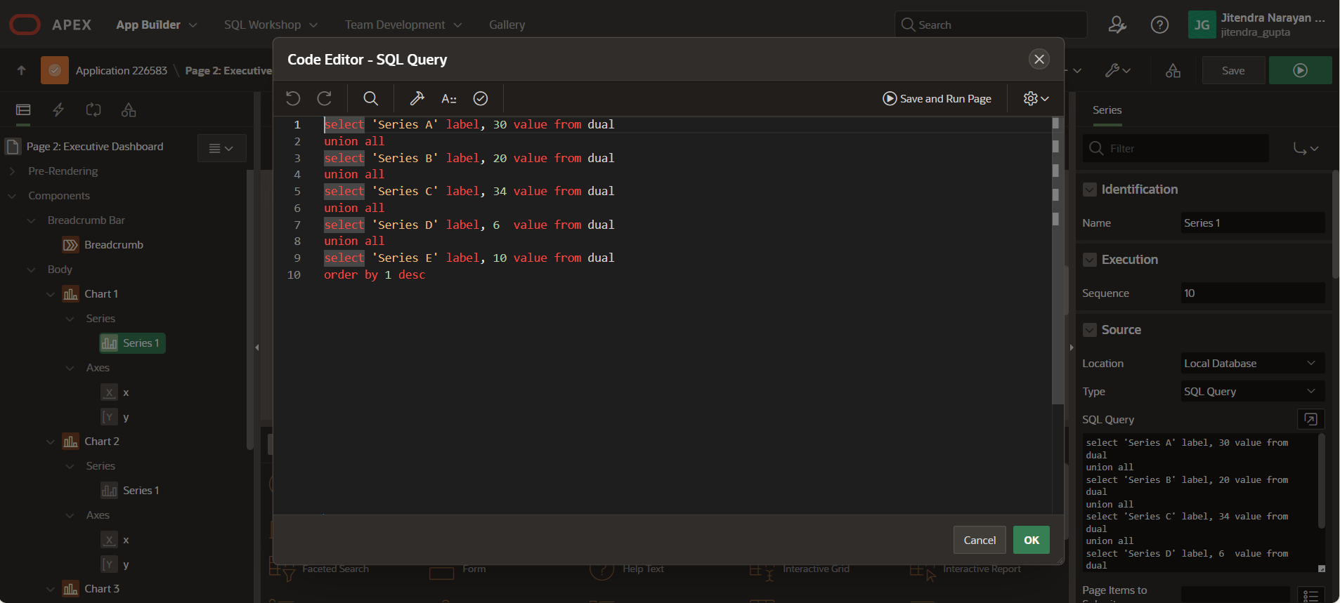
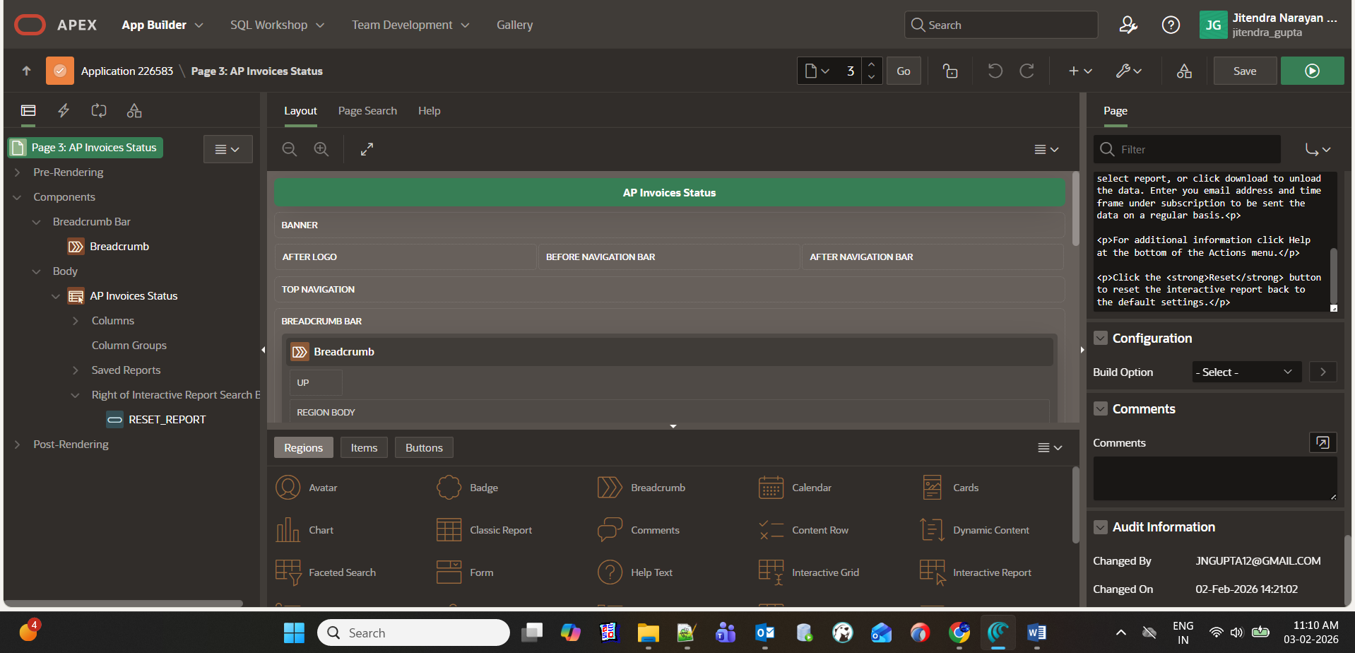

<p>To find data enter a search term into the search dialog, or click on the column headings to limit the records returned.</p>
<p>You can perform numerous functions by clicking the <strong>Actions</strong> button. This includes selecting the columns that are displayed / hidden and their display sequence, plus numerous data and format functions. You can also define additional views of the data using the chart, group by, and pivot options.</p>
<p>If you want to save your customizations select report, or click download to unload the data. Enter you email address and time frame under subscription to be sent the data on a regular basis.<p>
<p>For additional information click Help at the bottom of the Actions menu.</p>
<p>Click the <strong>Reset</strong> button to reset the interactive report back to the default settings.</p>

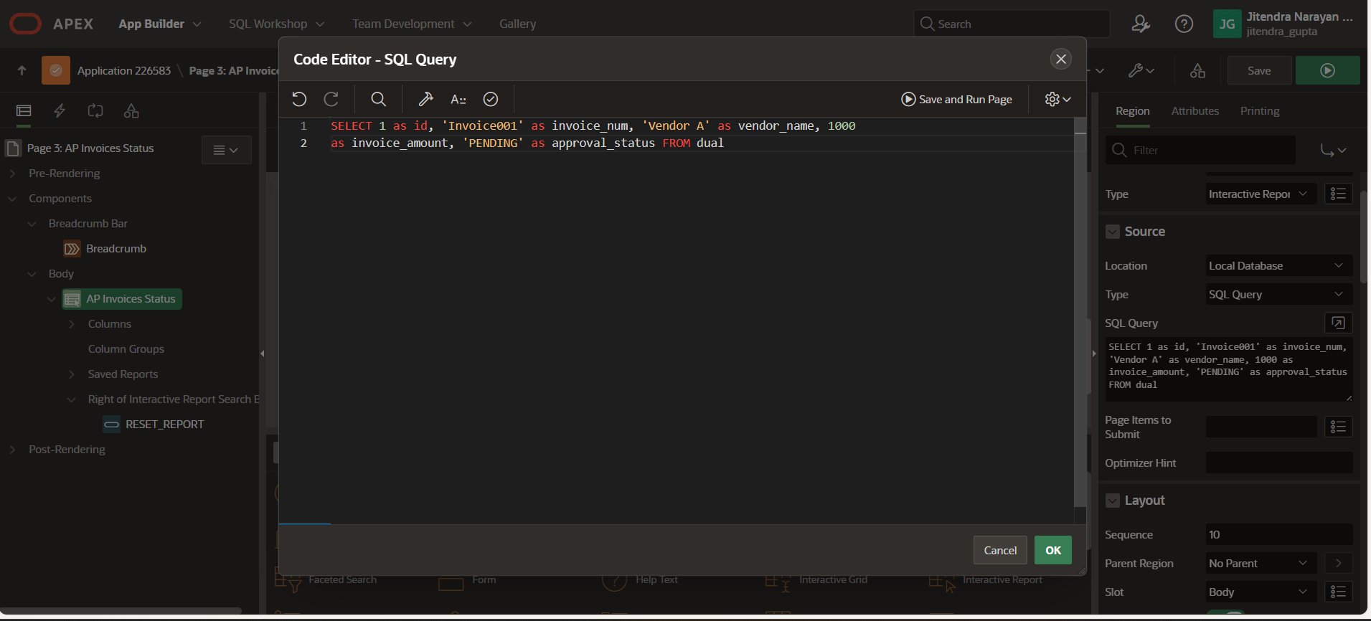
SELECT 1 as id, 'Invoice001' as invoice_num, 'Vendor A' as vendor_name, 1000
as invoice_amount, 'PENDING' as approval_status FROM dual
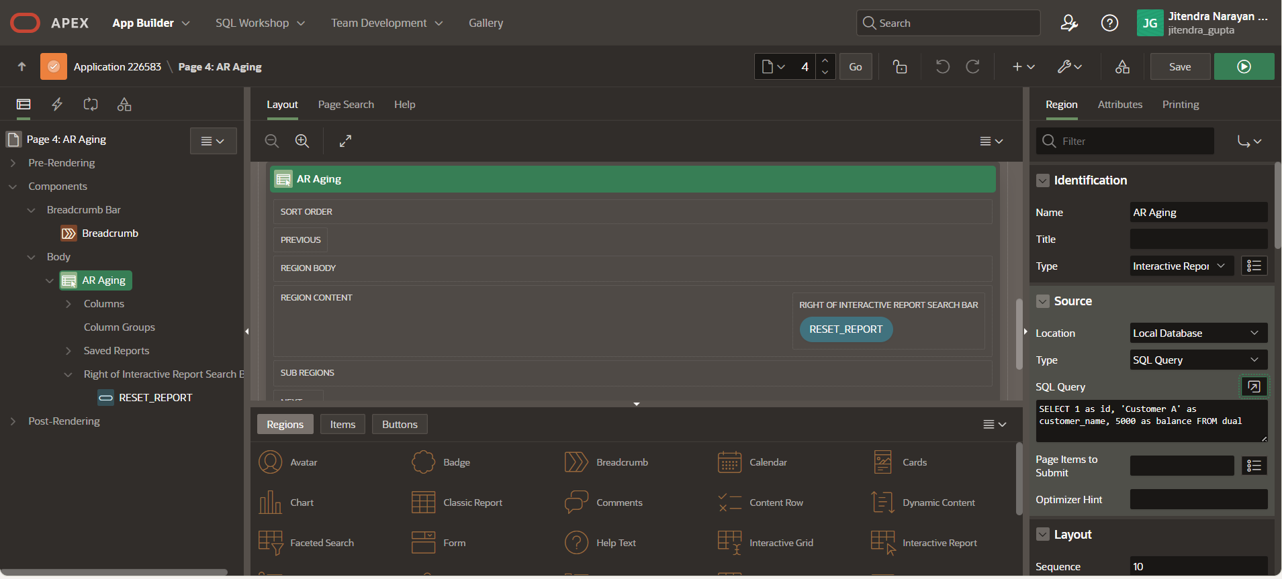

SELECT 1 as id, 'Customer A' as customer_name, 5000 as balance FROM dual

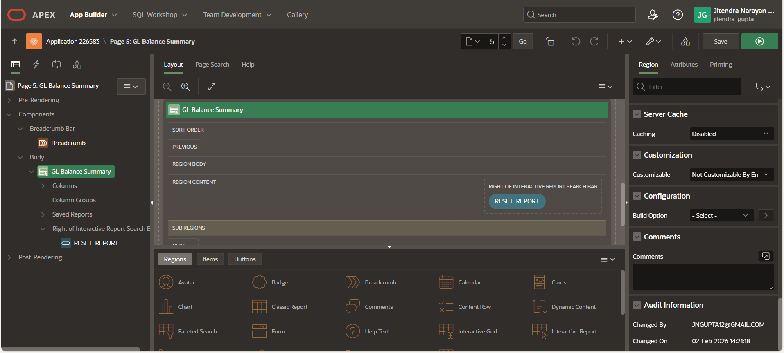

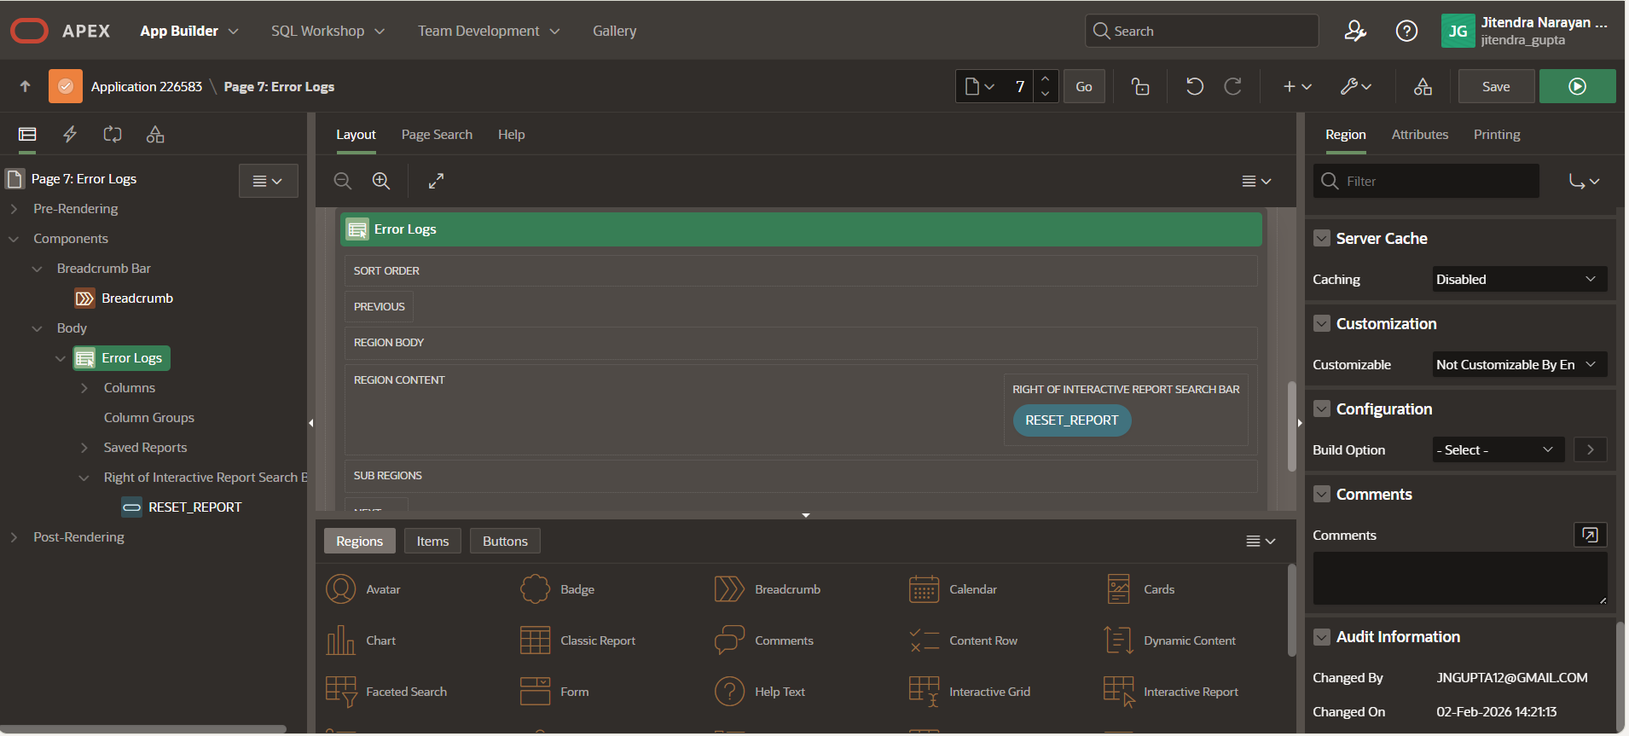

The dashboard provides executive-level KPIs, transaction monitoring, and REST API error tracking, similar to what enterprises require for ERP observability.

2️ Business Problem
In large ERP environments:
- Executives need real-time KPIs
- Finance teams need AP / AR / GL visibility
- Technical teams need REST API monitoring & error logs
- ERP data often comes from multiple systems
Traditional ERP screens are:
❌ Complex
❌ Not executive-friendly
❌ Poor in API observability

3️ Solution Architecture

🔹 High-Level Architecture
Oracle Fusion / EBS (Simulated)
|
| REST APIs (JSON)
v
Oracle APEX
├── PL/SQL API Layer
├── KPI Aggregation Logic
├── REST Log Tracking
└── Interactive Dashboards
|
v
Executives / Finance Users

4️ Database Design

🔹 KPI Summary Table
CREATE TABLE ERP_KPI_SUMMARY (
KPI_NAME VARCHAR2(100),
KPI_VALUE NUMBER,
LAST_REFRESH DATE
);
Purpose:
Stores aggregated ERP KPIs for fast dashboard rendering.

🔹 REST API Log Table
CREATE TABLE ERP_REST_LOG (
LOG_ID NUMBER GENERATED BY DEFAULT AS IDENTITY,
API_NAME VARCHAR2(100),
REQUEST_DATE DATE,
HTTP_STATUS NUMBER,
STATUS VARCHAR2(30),
ERROR_MSG VARCHAR2(4000)
);
Purpose:
Tracks REST API calls, failures, and debugging data (production-grade practice).

5️ PL/SQL Business Logic

🔹 KPI Refresh Procedure
CREATE OR REPLACE PROCEDURE refresh_kpis IS
v_ap_count NUMBER;
BEGIN
-- Demo values (replace with EBS/Fusion queries)
v_ap_count := 150;

DELETE FROM erp_kpi_summary;

INSERT INTO erp_kpi_summary
VALUES ('Pending AP Invoices', v_ap_count, SYSDATE);

INSERT INTO erp_kpi_summary
VALUES ('Total AR Outstanding', 250000, SYSDATE);

INSERT INTO erp_kpi_summary
VALUES ('GL Balance', 1500000, SYSDATE);

COMMIT;
END;
/

GL Balance Function
CREATE OR REPLACE FUNCTION get_gl_balance
RETURN VARCHAR2 IS
v_balance NUMBER;
BEGIN
v_balance := 1250000;
RETURN 'GL Balance is ' || v_balance;
END;
/
Usage:
- Used inside APEX reports
- Callable from REST APIs
- Clean function design (ACE reviewers like this)

6️ REST API Integration Pattern

REST Call Logging (Best Practice)
INSERT INTO erp_rest_log
(API_NAME, REQUEST_DATE, HTTP_STATUS, STATUS, ERROR_MSG)
VALUES
('GET_AP_INVOICES', SYSDATE, 200, 'SUCCESS', NULL);
On failure:
INSERT INTO erp_rest_log
VALUES
(NULL, 'GET_GL_BALANCE', SYSDATE, 500, 'FAILED',
'Fusion API timeout');
Why Oracle ACE reviewers love this:
✔ Production-ready logging
✔ Debug-friendly
✔ Real-world enterprise design

7️ Oracle APEX Application Design

🔹 Dashboard Pages
Page | Description
Executive Dashboard | KPI cards using ERP_KPI_SUMMARY
AP Invoices Status | Finance monitoring
AR Aging | Receivables visibility
GL Balance Summary | Financial snapshot
REST API Monitor | ERP_REST_LOG report
Error Logs | API failures & debugging

🔹 KPI Cards Query
SELECT
KPI_NAME,
KPI_VALUE,
LAST_REFRESH
FROM ERP_KPI_SUMMARY;

🔹 REST Monitor Report
SELECT
LOG_ID,
API_NAME,
REQUEST_DATE,
HTTP_STATUS,
STATUS,
ERROR_MSG
FROM ERP_REST_LOG
ORDER BY REQUEST_DATE DESC;

